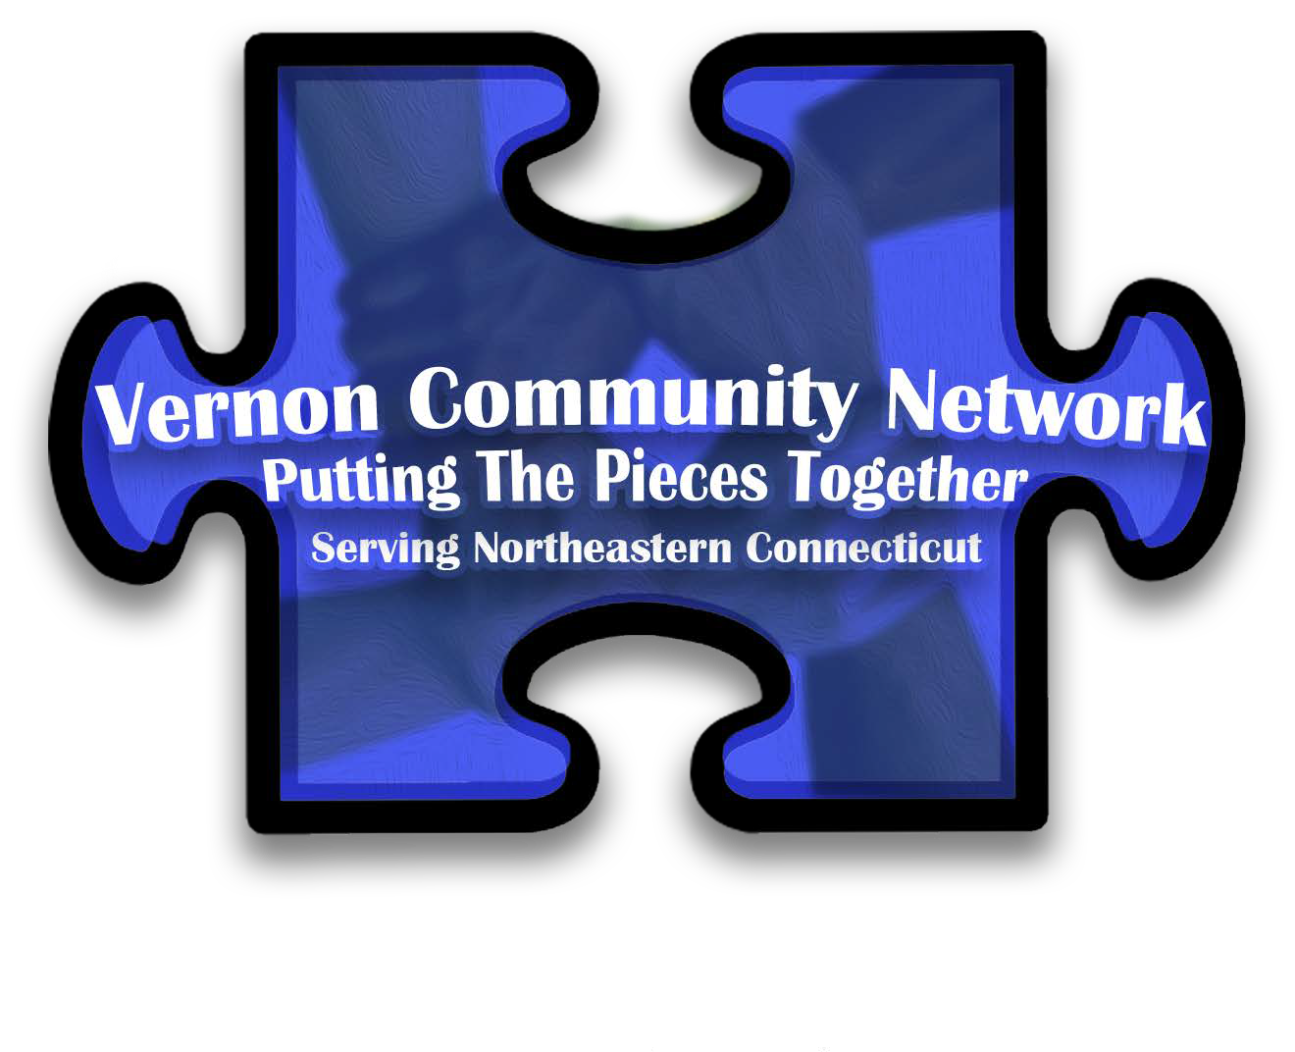

***“THE VERNON COMMUNITY NETWORK IDENTIFIES***

***AND COORDINATES RESOURCES FOR THE***

***ENRICHMENT OF THE COMMUNITY.”***

***Vernon Community Network***

***Membership Application***

Renewal: ☐

* New Member: ☐

Today’s date:

Agency Name:

Address:

Phone:

Fax: Cell: Web: Facebook: Twitter:

Email Address:

**Representative Information:** *Per the VCN By-Laws, each member agency may appoint two agency representatives with*

*only one representative having voting rights at any given meeting.*

*Representative Names:*

Title:

Title:

*Please list any other Organizations (Boards, Committees, Commissions, Task Forces, Working Groups, Clubs) you are*

*connected with that would be of interest to the VCN Membership:*

*Please suggest speakers/presentations for upcoming VCN Meetings:*

================================================================================================

* Article 2, Sec. 3 for the VCN By-Laws: New members either individual or agencies, upon application, shall be admitted to the Network subject to approval of the Executive Committee.

* Agency = $45 Annually
* Individual = $35 Annually

Membership Dues:

Please make your check payable to VCN and mail to:

Vernon Community Network

P.O. Box 1426 Vernon, CT 06066

For questions on membership, please contact Robin Kohler, [rkohler@kidsafect.org,](mailto:rkohler@kidsafect.org) 860-872-1918

================================================================================================

*VCN Use Only:*

*Check #:*

*Amount:*

*Date Written:*

*Date Received:*